**BUS RESERVATION SYSTEM**

*A*

*Mini Project Report*

*Submitted in partial fulfilment of the*

*Requirements for the award of the Degree of*

**BACHELOR OF ENGINEERING**

IN

**INFORMATION TECHNOLOGY**

By

BASIPAKA JOSEPH 1602-19-737-074

LUKKA SHIVA CHARAN 1602-19-737-103



**Department of Information Technology**

**Vasavi College of Engineering (Autonomous)**

**(Affiliated to Osmania University)**

**Ibrahimbagh, Hyderabad-31**

**2020**

1

**Vasavi College of Engineering (Autonomous)**

**(Affiliated to Osmania University)**

**Hyderabad-500 031**

**Department of Information Technology**



**DECLARATION BY THE CANDIDATE**

We, **LUKKA SHIVA CHARAN** and **BASIPAKA JOSEPH,** bearing hall ticket numbers, **1602-19-737-103** and **1602-19-737-074**, hereby declare that the project report entitled **“BUS RESERVATION SYSTEM”** Department of Information Technology, Vasavi College of Engineering, Hyderabad, is submitted in partial fulfilment of the requirement for the award of the degree of **Bachelor of Engineering** in **Information Technology**

This is a record of bonafide work carried out by me and the results embodied in this project report have not been submitted to any other university or institute for the award of any other degree or diploma.

LUKKA SHIVA CHARAN

1602-19-737-103

BASIPAKA JOSEPH

1602-19-737-074

(Faculty In-Charge) (Head,Dept of IT)

2

**Acknowledgements**

Firstly, The satisfaction that accompanies the successful completion of this project would not be in complete without the mention of the people who made it possible, without whose constant guidance and encouragement would have made efforts go in vain. We consider ourselves privileged to express gratitude and respect towards all those who guided us throughout the completion of this project and made it successful.

We convey our thanks to honourable Dr. Kovvur Ram Mohan Rao sir professor and Head of the Information Technology Department for arranging Mini Project sessions right from the second year itself. Inorder to help us build technical skills and ensuring our knowledge in programming languages reflects in application point of view as well.

We convey thanks to my project guide Mrs. Prasanna mam of Information technology Department for providing encouragement, constant support and guidance which was of a great help to complete this project successfully.

Last but not the least, we wish to thank our parents for continuously motivating us and for financing our studies in privileged Vasavi College of Engineering for persuing engineering from a reputed college.

3

**Abstract**

Our Mini Project is ‘**Bus Reservation System’.** We have taken this as our mini project inorder to conclude the problems faced by the people while booking the tickets. Our Bus Reservation System includes the features like login, members details, journey details payment and etc. We have added a new feature to the existing bus reservation system is that the person can select different boarding points to get into the bus. The one more additional thing is the person will be given a code while booking the ticket which he needs to enter while he is going to get down from the bus, so that we can keep a track of the person’s boarding and destination points. If in case the person get downs before the destination point which he has mentioned while booking the tickets, we will have the information of the person. We have increased the boarding points so that the person can his bus at a minimal distance of 20km from the boarding point. We have got 3-4 boarding points for the buses mentioned in the buses list. Through our bus services one can travel anywhere in a minimum possible time based on the buses routes. We have designed this to be a user friendly guide and take care of the users and respect their time and money as well.

4

**TABLE OF CONTENTS**

|  |  |  |
| --- | --- | --- |
| S.No. | NAME OF THE TOPIC | PAGE NO. |
| 1. | Introduction | 6-8 |
| 2. | Technology | 9 |
| 3. | Proposed Work | 10 |
| 3.1 | Design | 10 |
| 3.2 | Implementation | 13 |
| 3.3 | Testing  3.3.1 Test Plan  3.3.2 Use Cases | ALL from 17 |
| 4 | Results | 20-24 |
| 5 | Additional Knowledge | 25 |
| 6 | Conclusion and Future Work | 26 |
| 7 | References | 27 |

5

**1.INTRODUCTION**

**ABOUT THE PROJECT**

“BUS RESERVATION SYSTEM IN C” is a console-based c project which helps in booking tickets quickly. The administrator stores the details of the user like name, age, boarding and destination points and date of journey into a file. There are two actors to run our project i.e. the user and the admin, if in case user prompts something wrong then admin displays an error.

## 1.1 PROJECT DOMAIN

Bus reservation system is a common task we are familiar through. We have many problems while booking tickets like the boarding points, buses unavailability at a particular time and so on. We have introduced a unique feature in to the existing system is we have increased the boarding points for the user within the 20-25 kms of the bus starting point. We maintain the records of a passenger safely no outsider can get any info of the passenger.

We ensure safety for our passengers, our system helps you in booking tickets very quickly. No such errors will occur during the booking of a ticket like server breakdown and so on and so fourth. You can quickly login into the portal by a signing if you are a old user with the following credentials like username and password. If you are a old user, you can quickly register and just get the details of your bus by entering from and to details. On logging in only you will be able to book tickets for your desirable locations.

We provide various kinds of buses depending upon the user affordability and comfort for user friendly with the customers. It helps the admin to maintain the details in a effective manner.

**Purpose**

The main purpose of building this project is to remove the difficulties faced by the people while booking tickets like they want more boarding points and some cannot afford high rates so tried to increase the boarding points by 2-3 and are arranged them very close to the starting point of the bus. We provide an user friendly interface in a simple way to book tickets. Enjoy riding with us at a cheaper rate. We ensure the time and money of the customer i.e. by the bus route which takes a less time to travel through his destination.

6

**Benefits**

* Efficient and cheaper booking.
* More boarding points.
* User details are hidden.

**1.2 FEATURES**

In this project the user can login if he is a old user else he needs to register through the portal. The user needs to enter from and to address apart from the user can select the boarding points , bus types, no. of tickets and date of journey.

**1.2.1 Login**

The user can simply login to our page ,if he is an old user by entering the following credentials and book tickets as per requirement.

**1.2.2 Register**

The new needs to register to our page but on registration he can only access the bus fare but he can’t book tickets.

**1.2.3 Process**

It includes login and registration parts.

**1.2.4 Bus Details**

It allows the user to enter to and from addresses and gets to know the available boarding points for that location.

**1.2.5 Boarding points**

It allows the user to select the desired boarding point. 7

**1.2.6 Buses list**

It shows the user the various types of buses available for your chosen journey details.

**1.2.7 Buses type**

User can select the type of bus and tickets based on the information it calculates price and displays it.

**1.2.8 Members details**

It captures the details of the person like name, age, phone number and gmail id.

**1.2.9 Date**

It allows the user to select the date of journey.

8

**2.TECHNOLOGY**

All computer software needs certain hardware components or other software resources to be present, in order for computers to be used efficiently. These prerequisites are known as System Requirements. Within this, we have two types – Software Requirements and Hardware Requirements.

## SOFTWARE REQUIREMENTS

Software Requirements deal with defining the software resource requirements and prerequisites that need to be installed on a computer to provide optimal functioning of an application. These preconditions are generally not included in the software installation package and need to be installed separately.

In order to use CODIAC, one should have the following:

* **Operating System:** Windows 7 and above
* **C Compiler:** GNU Compiler Collection (GCC)
* **Editor:** Any text editor .

## HARDWARE REQUIREMENTS

Hardware requirements refer to the common set requirements defined by any operating system or software application and are usually the physical computer resources. In this, we look into the architecture, processing power, memory, secondary memory, display adapter and peripherals.

In order to use this project, one should have the following:

* + - **Processor:** Intel Pentium processor and above
    - **Memory:** 4 GB RAM and above

9

**3.PROPOSED WORK**

**DESIGN**

Our approach in designing Bus Reservation System is to reduce cost for travelling and increase the boarding points for the customer (user).

**USE CASES**

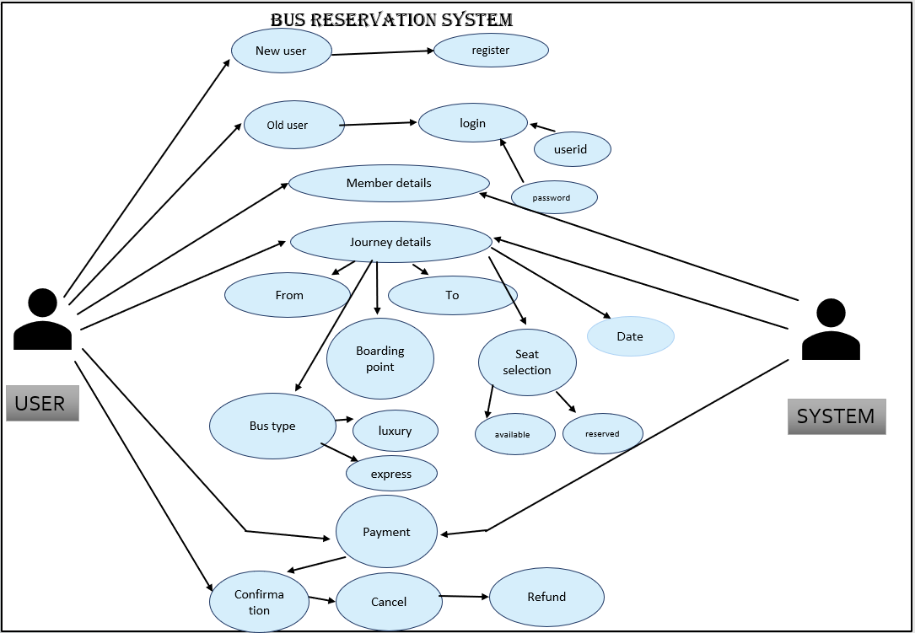

**FLOWCHART**

10

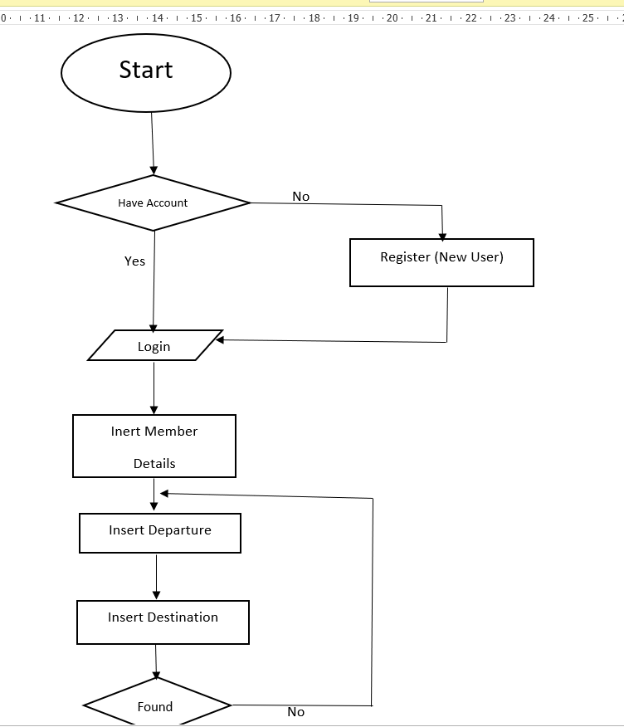

**11**

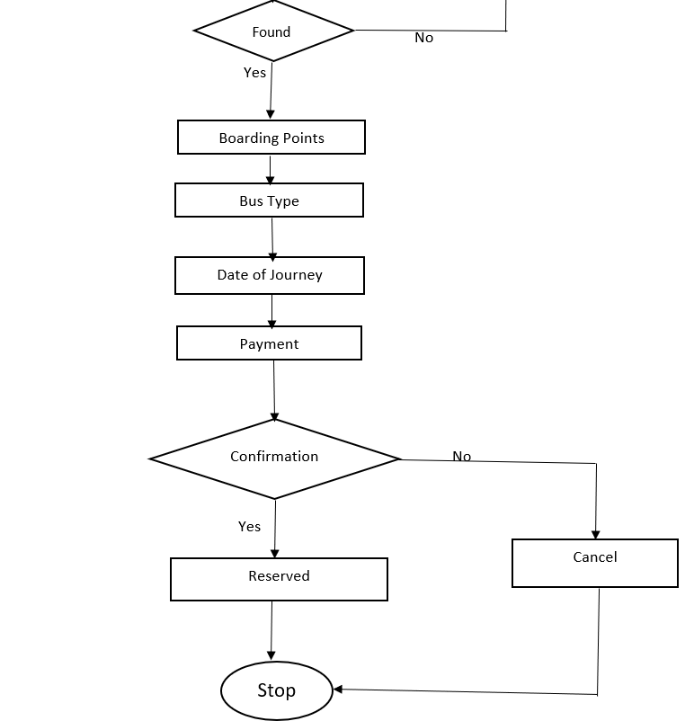

**12**

## 3.2 IMPLEMENTATION

Based on the use cases, we have implemented this project by dividing the work into modules – Register, Login, Bus details, Bus type, Buses list, Bus details, Member details, Date, Boarding points.

**3.2.1 LOGIN**

The user have to login with the predefined credentials i.e. username and password. If the password and username are attempted incorrectly or not registered it prompts again and again so if you are a new user u need to register and login.

**3.2.2 SIGNUP**

If the user is a new one then the user needs to sign up by entering username and password. Password needs to be in the required format i.e., first letter should be a capital letter otherwise the admin prompts an error of password incorrect back to the user until and unless he enters the password fulfilling all the desired things.

**3.2.3 BUS DETAILS**

It prompts the user to enter the to and from address and displays the boarding points allotted to it.

**3.2.4 BOARDING POINTS**

It asks the user to select the boarding point from the above displayed boarding points that are allocated to a particular from and to address.

**3.2.5 BUS TYPE**

It first displays the types of buses available and then asks the user to enter number of tickets and the bus type based in these it calculates the fare for the journey.

**3.2.6 BUS LIST**

It just consists of various types of buses available for all the locations.

13

**3.2.7 MEMBER DETAILS**

It asks the user some information like name, age, phone number and Gmail Id. To keep a track of booking details.

**3.2.8 DATE**

It just asks the user to enter the date of journey

**BUSES LIST**

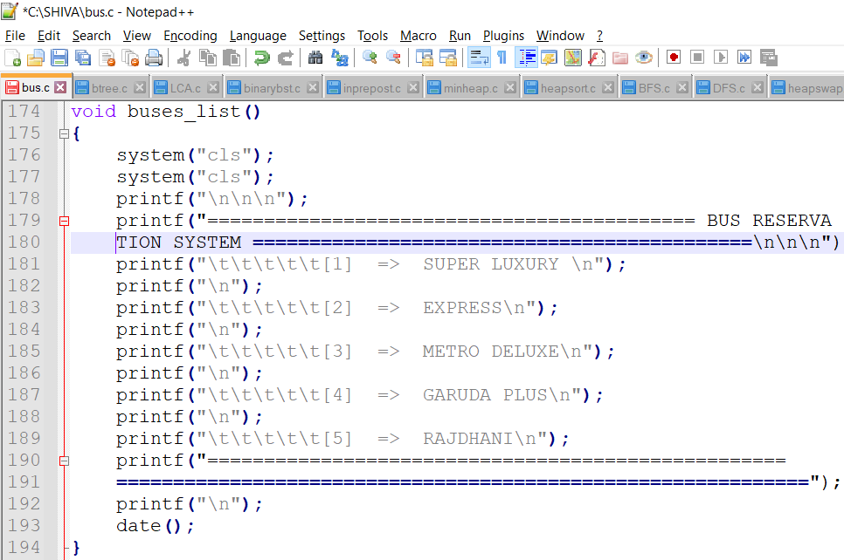

**BUS TYPE**

**14**

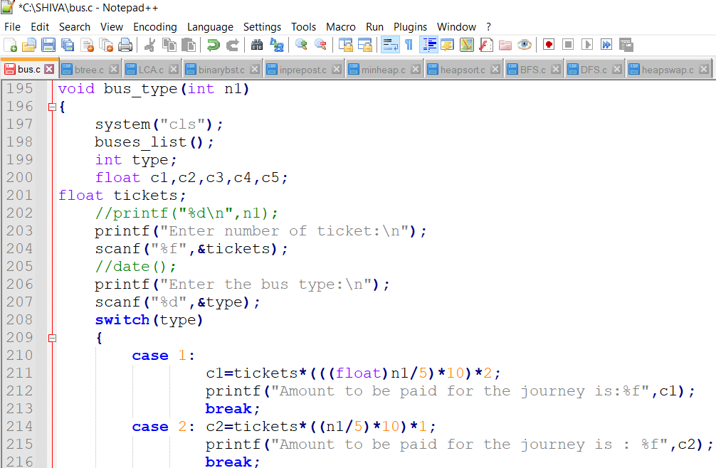

**12**

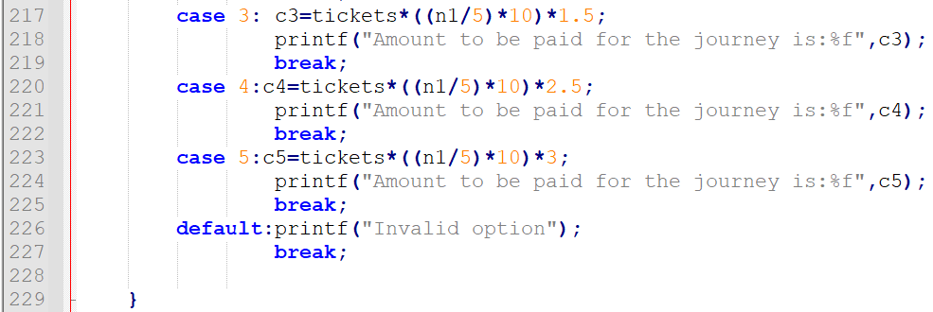

**15**

**Algorithm**

Step 1 : We will display the boarding points and then he needs to select the boarding point from the mentioned ones.

Step2: After selection of boarding point, boarding point to destination distance is displayed.

Step 3 : After pressing Enter The bus list is displayed on the screen.

Step 4 : Enter the date of journey and enter the details like name, age, phone number and Gmail Id.

Step 5 : Enter number of tickets and select the bus type. By the above details we can calculate the fare for the journey.

Step 6 : If the entered from address is MULUGU and to address is GADWAL then it shows 3-4 boarding points among that if we select ADILABAD.

Its showing round 515km and 8:35hr journey.

For that the bus type I choose is 1 i.e. Super Luxury and number of tickets is 2.

Calculation of journey fare:

C1=cost,n1=distance from boarding point, tickets= number of tickets.

So, **c1=tickets*(((float)n1/5)*10)*2** is the formula to find fare.

C1=2*((float)515/5)*10)*2

C1=2*((float)103)*10)*2

C1=2*103.00*10*2=4200.00 13

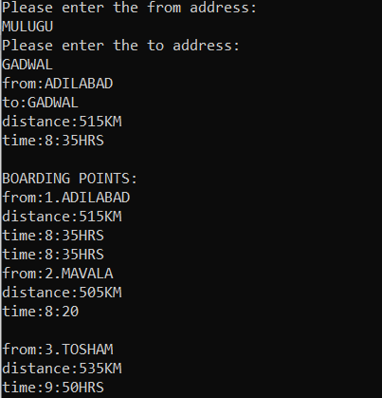

16

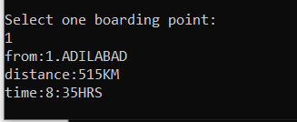

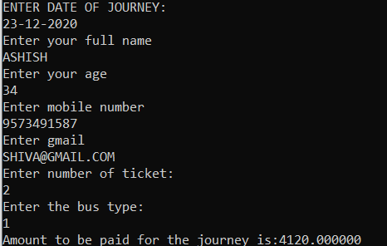

## 

## 

## 16

## 3.c TESTING

Testing is a method to check whether the actual product matches the expected requirements and to ensure that the product is defect-free. This process involves execution of various parts of the product either using manual or automated tools. The purpose is to identify errors, gaps or missing requirements in contrast to the actual requirements.

**3.c.1TEST PLAN**

We approached testing our console application by analyzing each module separately. First, we coded the requirements and then manually tested each feature present in the module to cover any gaps that might occur.

**3.c.2USER TEST CASES**

The user has 6 major functionalities: Registration, Login, Member Details, Journey Details, Payment, Confirmation. Below are the testcases which we have compiled together manually.

**1.login**

**2. register**

**3. member details**

|  |  |  |
| --- | --- | --- |
| **Test Case Template** | | |
| **Test Case ID:** TC01 | | **User Case ID:**  UID01 |
| **Test Case Title:** Registration | |
| **Test Case Description:** New user attempts to register into the application to create an account | |
| **Test Steps:** | **Expected Result:** | **Actual Result:** |
| System displays prompt for user to enter username  and password(predefined) | If user validates the information and the details are correct, then creates an account and gives error if not entered correctly | The details were entered correctly, a new account is created. |

17

|  |  |  |
| --- | --- | --- |
| **Test Case Template** | | |
| **Test Case ID:** TC02 | | **User Case ID:**  UID02 |
| **Test Case Title:** Login | |
| **Test Case Description:** User should have an account. | |
| **Test Steps:** | **Expected Result:** | **Actual Result:** |
| System displays prompt for user to enter username  and password(predefined) | If user validates the information and the details match with registered records, then displays loin successful If any entered details does not match with the records,  displays error and prompts user to login again. | If Login ID and Password matches displays login successful and display the details or else displayed login unsuccessful. |

|  |  |  |
| --- | --- | --- |
| **Test Case Template** | | |
| **Test Case ID:** TC03 | | **User Case ID:**  UID03 |
| **Test Case Title:** Member Details | |
| **Test Case Description:** User should enter the details. | |
| **Test Steps:** | **Expected Result:** | **Actual Result:** |
| System displays prompt for user to enter name, age, contact details and Gmail | Accepts all the info entered by the user and store everything in a file. | Accepts information provided by user and appended in file. |

**4.Journey details**

**5. payment details**

**18**

|  |  |  |
| --- | --- | --- |
| **Test Case Template** | | |
| **Test Case ID:** TC04 | | **User Case ID:**  UID04 |
| **Test Case Title:** Journey Details | |
| **Test Case Description:** User should enter the details. | |
| **Test Steps:** | **Expected Result:** | **Actual Result:** |
| System displays prompt for user to enter  the details like From address, To address, Boarding points, Bus type, Date of Journey and No of Tickets. | Accepts all the info entered by the user and displays the ticket fare for Journey. If the From or To address are misspelled or incorrect prompts reenter and everything is stored in a file. | Accepts information provided by user and displays fare of journey. |

|  |  |  |
| --- | --- | --- |
| **Test Case Template** | | |
| **Test Case ID:** TC05 | | **User Case ID:**  UID05 |
| **Test Case Title:** Payment Details | |
| **Test Case Description:** User should Pay the Fare for journey. | |
| **Test Steps:** | **Expected Result:** | **Actual Result:** |
| System displays prompt for user to Pay the Fare of Journey. | User should pay the Fare of journey through net banking or BHIM UPI and if payment is successful asks for conformation of ticket. | Fare of Journey should be paid by user to book ticket. |

|  |  |  |
| --- | --- | --- |
| **Test Case Template** | | |
| **Test Case ID:** TC06 | | **User Case ID:**  UID06 |
| **Test Case Title:** Confirmation | |
| **Test Case Description:** User should confirm after paying fare. | |
| **Test Steps:** | **Expected Result:** | **Actual Result:** |
| System displays prompt for user to confirm ticket to reserve. | Confirmation by the user and message is received by the user about reserved ticket. | Confirmation message is received or displayed about the reserved ticket. |

**6.Confirmation**

19

# **RESULTS**

# USING LOGIN OPTION

# 

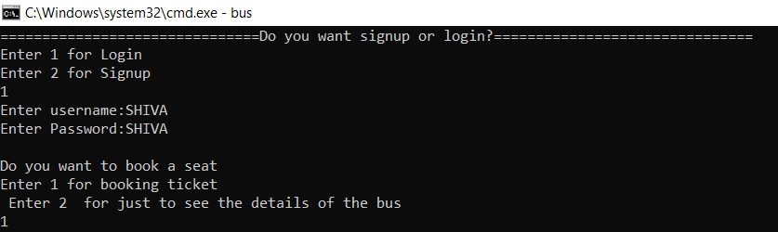

20

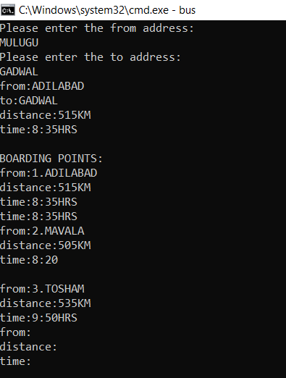

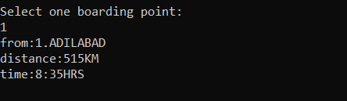

21

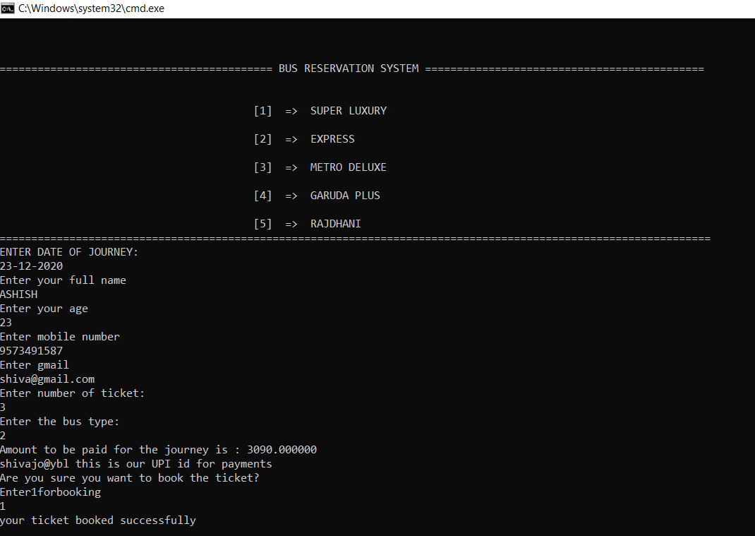

USING SIGN UP OPTION

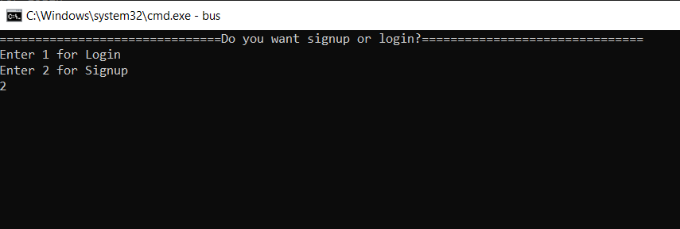

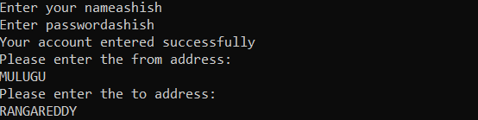

22

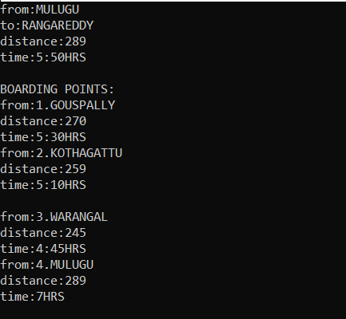

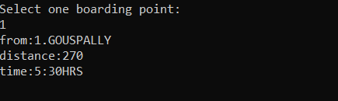

23

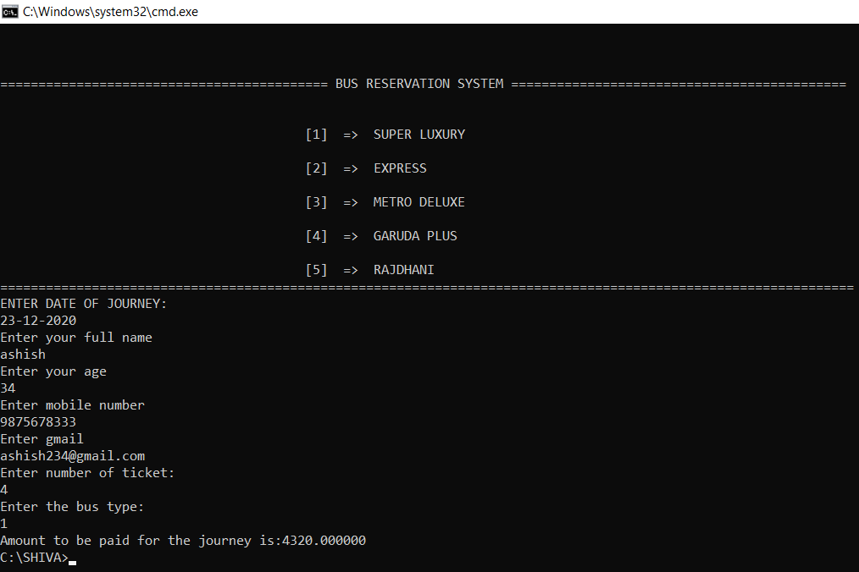

24

# **ADDITIONAL KNOWLEDGE ACQUIRED**

Implementing this project in C Language has introduced us to different libraries such as: ‘conio.h’, ‘ctype.h’. We were able to use the knowledge we have on the Linked List Data Structure and execute it as a real-time application. We explored the ‘conio.h’ libraries for achieving a look-and-feel of an actual window application by constructing our own time delay function.

Also, we have further improved in our knowledge in file-handling because of the vast amount of data manipulation we have done using text files.

We studied a lot about strings, and it is very awful using them. It is like playing with strings I mean if we assign a string then we can display every detail with a single digit.

Other than this, we have learnt the value of team spirit and have understood the intention behind working in teams. We have learnt to be team players.

25

# **CONCLUSION AND FUTURE WORK**

To conclude, this application is useful not only for Transport Department but It helps the user to understand everything and without any confusion can reserve a bus ticket.

Future work is to we develop the application in PHP Or HTML to make the real payment, make this console application as a web application.

26

# **REFERENCES**

# 1.C Language Documentation:

# [https://docs.microsoft.com/en-us/cpp/c- language/?view=msvc-160](https://docs.microsoft.com/en-us/cpp/c-language/?view=msvc-160)

2.Visual Studio Code:

3.Stack Overflow (for debugging errors): <https://stackoverflow.com/>

27